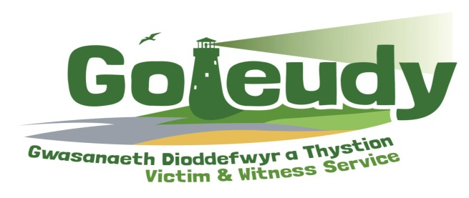
Volunteer Role Profile – Administrative Support Volunteer

Who are Goleudy?
Goleudy is an independent service commissioned by the Office for the Police and Crime Commissioner (OPCC) for Dyfed Powys.

Our aim is to engage all victims and witnesses involved in the Criminal Justice process, ensuring that they are fully supported, listened to and have a voice throughout the Criminal Justice System.

The Role
You will help to support Goleudy staff at Headquarters, ensuring that we can continue to provide the assistance and support needed by victims. This post is open to anyone over the age of 18.

Role Requirements
• General administrative tasks such as filing, photocopying and faxing.
• To help arrange events and meetings, booking venues/rooms where necessary.
• To prepare information and documents.
• To compile and maintain correct and current minutes.
• To collate statistics and help to prepare reports.
• To arrange staff and volunteer meetings.
• To contact staff and external contacts.
• To research and develop contact databases.
• To operate as a main point of contact for visitors and telephone enquiries.

Your Commitment
This role is flexible, however you will need to be available during office hours (9am – 5pm) from Monday to Friday, for at least 4 hours a week.

Necessary skills, values and abilities
- Good IT skills, including use of Microsoft Office.
- Good written and communication skills.
- Ability to deal with vulnerable people in a sensitive and professional manner.
- Ability to prioritise and manage workload.
- Flexible, innovative and self-sufficient.
- Accuracy and attention to detail.
- Respect for the diversity of our members and clients.
- Prepared to work within our values, procedures and policies.
- Friendly, dependable, approachable and confident team member.

Opportunities and Benefits
• Full induction programme, one to one support for the role and the opportunity to develop new skills and gain excellent training.
• To learn about the work and practices of criminal justice agencies.
• An opportunity to join a dedicated and supportive team.
• An opportunity to engage with a wide range of people and diverse community groups.
• Agreed costs will be paid.

